
THE ISLAMIA UNIVERSITY OF BAHAWALPUR
SOFTWARE REQUIREMENT SPECIFICATION (SRS)
CHILD VACCINATION SYSTEM
Submitted By: FARIA BATOOL
Roll No: F22BINFT1M01195
Submitted To: Sir Muzammil ur Rehman

Table of Content

1. Introduction
1.1 Purpose
1.2 Scope
1.3 Product Perspective
1.4 User Characteristics

2. Requirements
2.1 Functional Requirements
FR001 – Signup
FR002 – Login
FR003 – Add Record
FR004 – Edit Record
FR005 – Delete Record
FR006 – Search
FR007 – Sort
FR008 – Export CSV
FR009 – Generate Certificate
FR010 – Vaccine Summary
FR011 – Next Dose Reminder
2.2 Non-Functional Requirements

3. Use Cases & Diagrams
3.1 Use Case UC001 – Sign Up
3.2 Use Case UC002 – Login
3.3 Use Case UC003 – Manage Records

4. Data Model & Diagrams
4.1 Data Structures (users, records)
4.2 Next Dose Schedule Logic
4.3 DFD Level 0
4.4 DFD Level 1
4.5 UML Class Diagram

Appendix – Key Code Snippets
A.1 localStorage Keys
A.2 nextDoseSchedule Structure
A.3 Certificate Generation Code
A.4 CSV Export Code

1. Introduction
The Child Vaccination System is a client-side web application implemented using HTML, CSS and JavaScript. The application enables healthcare staff to register, log in, and manage child vaccination records in an offline-capable manner by persisting data in the browser's localStorage. The system includes functionality for adding, editing, deleting and searching vaccination records, sorting records, exporting data as CSV, generating printable vaccination certificates, and presenting summaries of administered vaccines along with next-dose reminders.

1.1 Purpose
The purpose of this system is to provide small clinics and healthcare workers with a simple, reliable and offline-capable tool to manage child vaccination records. It reduces manual record-keeping, enables quick retrieval of patient data, and improves follow-up through automated next-dose reminders.

1.2 Scope
In scope: user signup/login, record management (add/edit/delete), search and sort, CSV export, certificate generation, vaccine summary, and next-dose reminders. Out of scope: server-side database integration, role-based access beyond basic login, SMS/email notifications, and national registry integration.

1.3 Product Perspective
This module operates entirely client-side and is suitable for small clinics or temporary setups where internet access may be limited. It can be integrated later with server-side APIs for backup and multi-user synchronization.

1.4 User Characteristics
Primary users are healthcare workers and clinic record keepers with basic computer literacy. Users expect a clear and minimal UI, instant responsiveness, and printable outputs (certificates).

2. Requirements

2.1 Functional Requirements
ID | Name |  | Description
FR001 | Signup |  | Create a new user account stored under the 'users' key in localStorage.
FR002 | Login |  | Authenticate an existing user and set 'currentUser' in localStorage.
FR003 | Add Record |  | Add child vaccination record with fields name, age, vaccine, date and save under 'records'.
FR004 | Edit Record |  | Modify an existing record by index and update localStorage.
FR005 | Delete Record |  | Remove a record from 'records' and update summaries.
FR006 | Search |  | Filter records by child name using client-side string matching.
FR007 | Sort |  | Sort records by name, age, or date using JavaScript sort functions.
FR008 | Export CSV |  | Generate and download a CSV file containing all records.
FR009 | Generate Certificate |  | Open a print-ready certificate in a new window for a selected record.
FR010 | Vaccine Summary |  | Count and display the number of vaccinations per vaccine type.
FR011 | Next Dose Reminder |  | Calculate future dates for next doses based on a schedule object in code.

2.2 Non-Functional Requirements
Usability: Simple UI targeted at users with basic computer skills.
Reliability: Data persisted using localStorage; stable for offline use but no central backup.
Performance: All operations are client-side and execute instantly for small datasets.
Portability: Runs in modern browsers (Chrome, Firefox, Edge).
Security: Basic authentication stored in localStorage (not encrypted); recommended future enhancement: hashed passwords and server-side auth.

3. Use Cases & Diagrams

Use Case - Sign Up
Use Case UC001 - Sign Up:
Actor: User (Healthcare Staff)
Description: Allows a new user to register by providing a username and password. The system stores user credentials in localStorage under the 'users' key. On successful registration, user is redirected to login screen.
Preconditions: User is not already registered.
Postconditions: New user object appended to 'users', and a success notification displayed.
Basic Flow: 1) Navigate to Sign Up -> 2) Enter username & password -> 3) Validate inputs -> 4) Save to localStorage -> 5) Show success message.
Exceptions: Username already exists; missing fields.
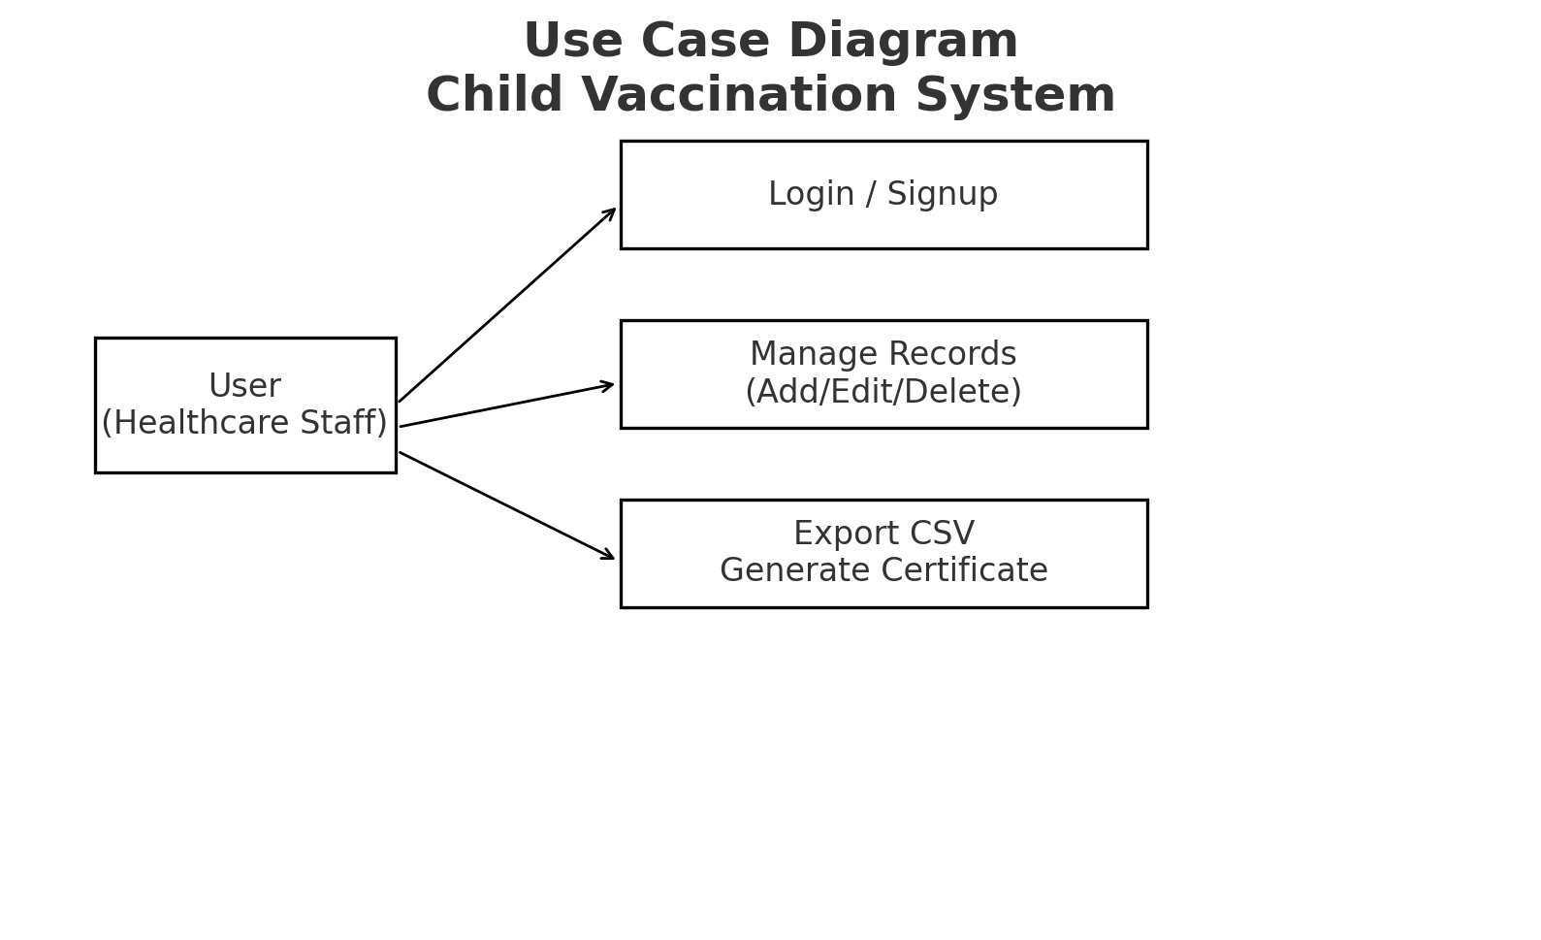

Use Case - Login
Use Case UC002 - Login:
Actor: User
Description: Authenticate user using stored credentials in 'users'. If credentials match, store 'currentUser' and display dashboard.
Basic Flow: 1) Enter credentials -> 2) Check against 'users' array -> 3) On match set 'currentUser' -> 4) Load dashboard.
Exceptions: Wrong username or password; no users registered.
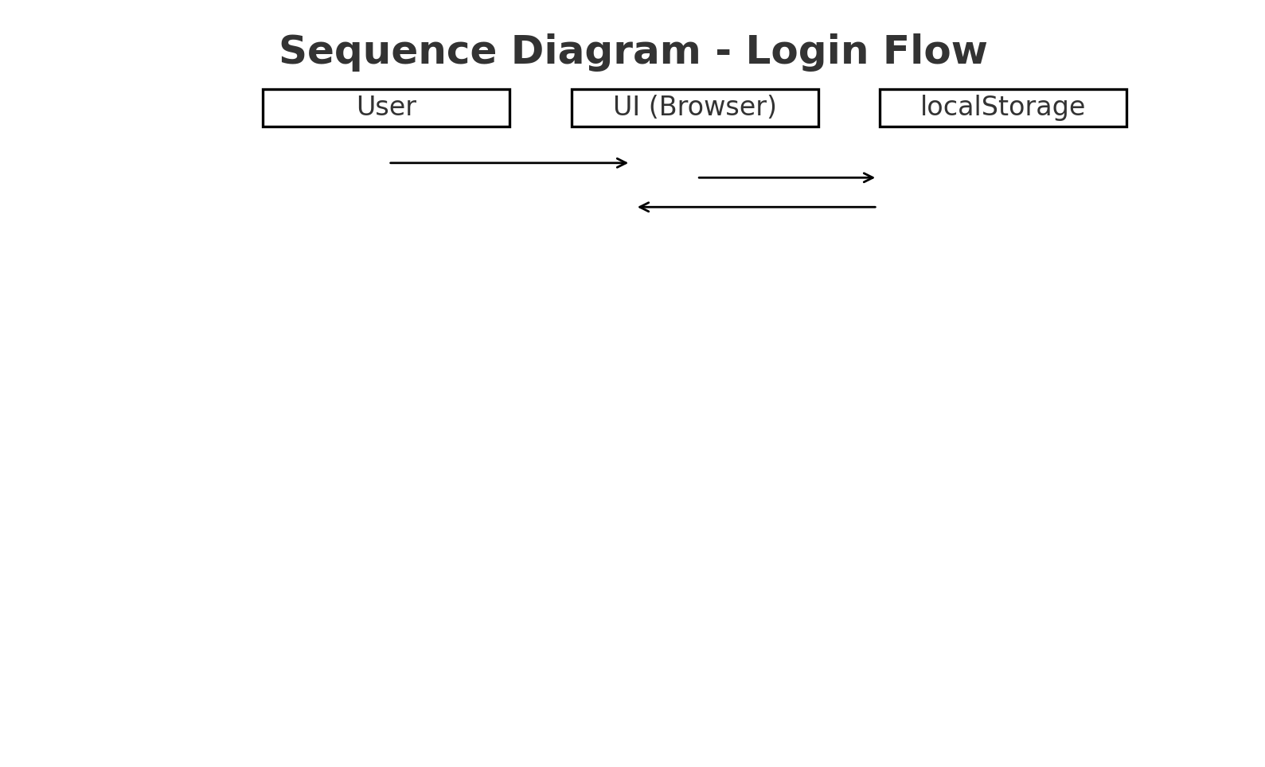

Use Case - Manage Records
Use Case UC003 - Manage Records:
Actor: User
Description: Add, edit, delete and view child vaccination records. Each record contains name, age, vaccine, and date. Records are stored in 'records' key in localStorage and displayed in a tabular format on the dashboard.
Basic Flow: 1) From dashboard, input child details -> 2) Validate -> 3) Append or update 'records' -> 4) Refresh the display and summaries.
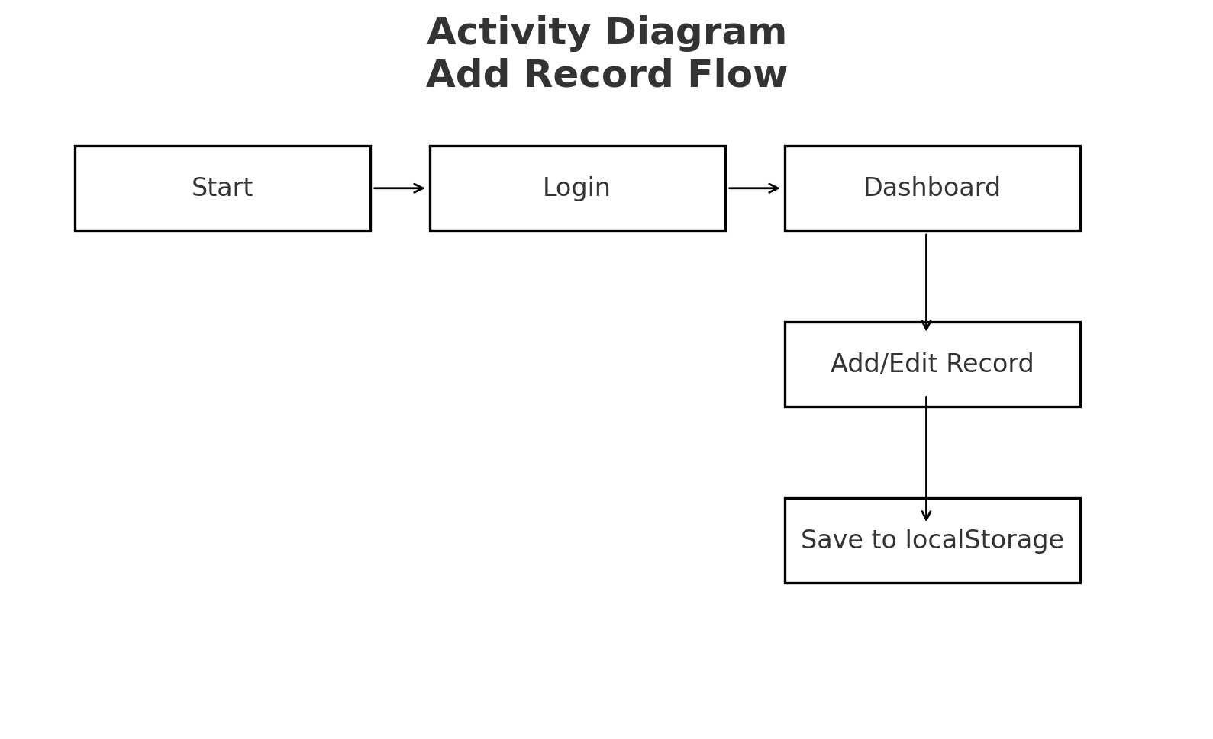

4. Data Model & Diagrams
The application stores two main data structures in localStorage:
1) users: an array of {username, password} objects used for authentication.
2) records: an array of vaccination record objects {name, age, vaccine, date}.
Each record is validated at input time. The 'nextDoseSchedule' object in code defines intervals (in days) for follow-up doses:
Polio: 30, BCG: 0, Hepatitis B: 30, Measles: 60, Tetanus: 90.
The system computes next dose dates by adding the schedule interval to the vaccination date and displays them in the dashboard.
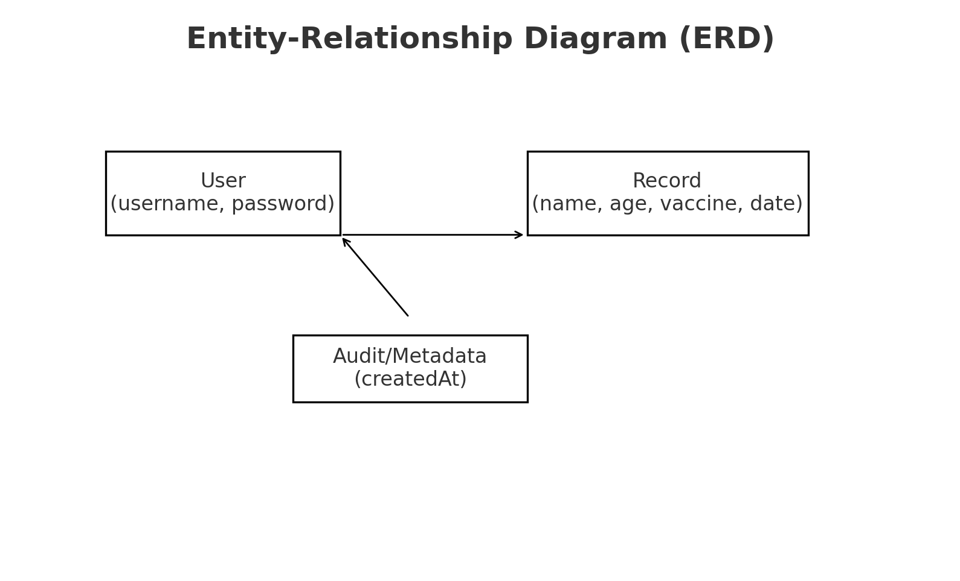

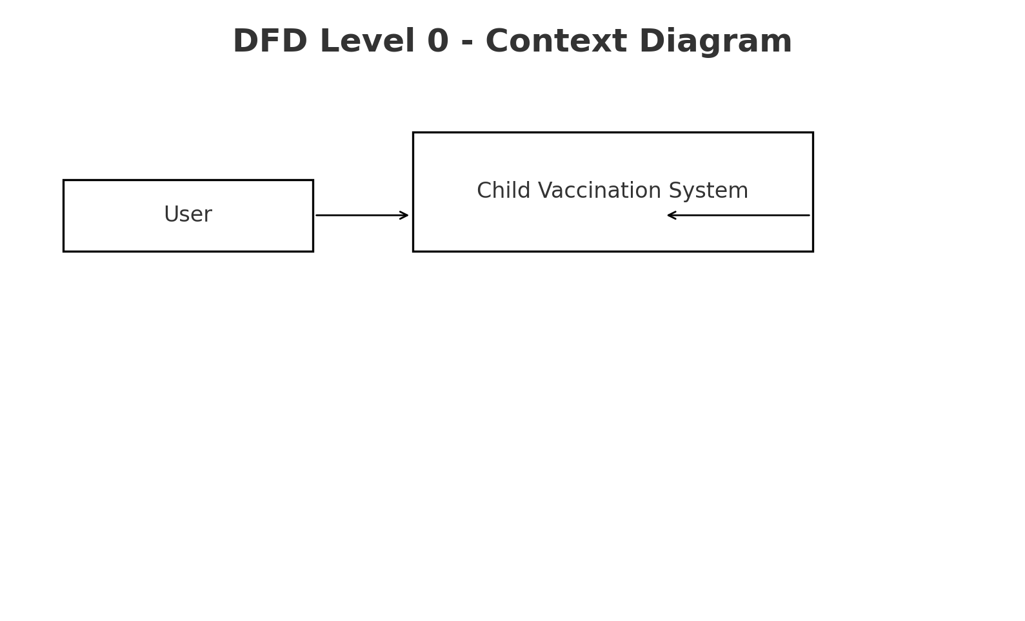
DFD Level 0

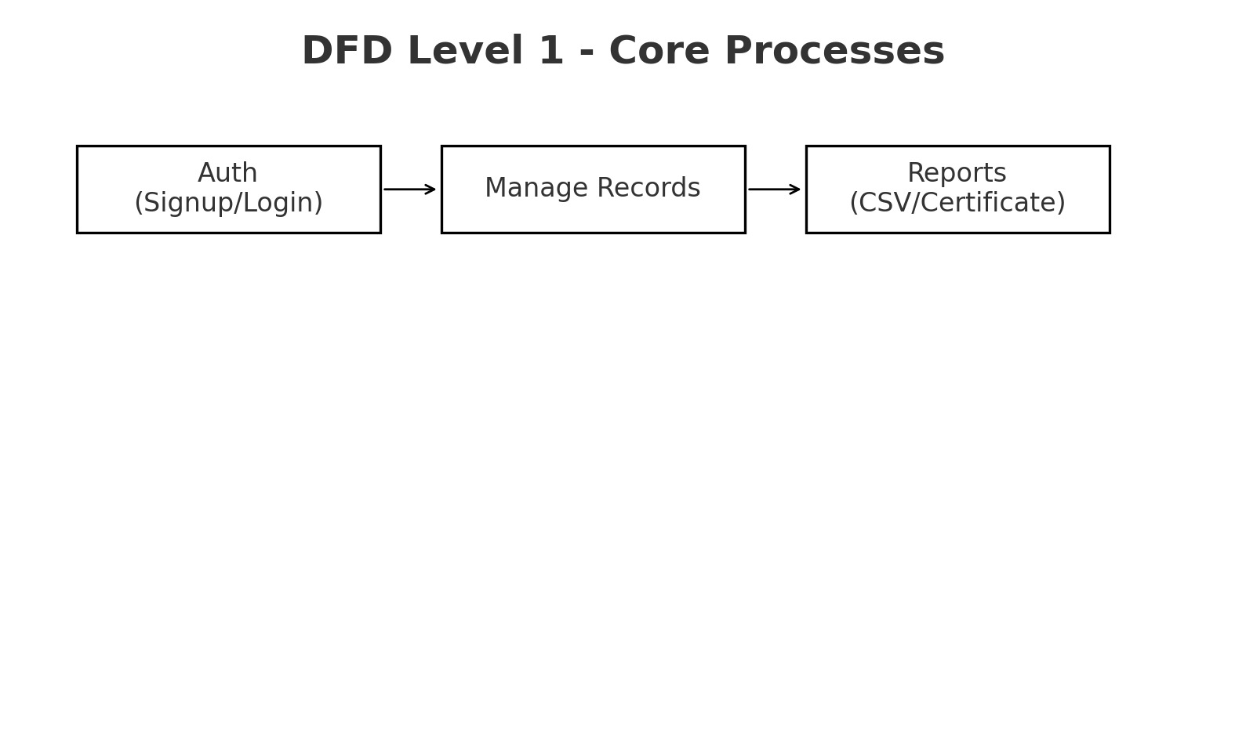
DFD Level 1

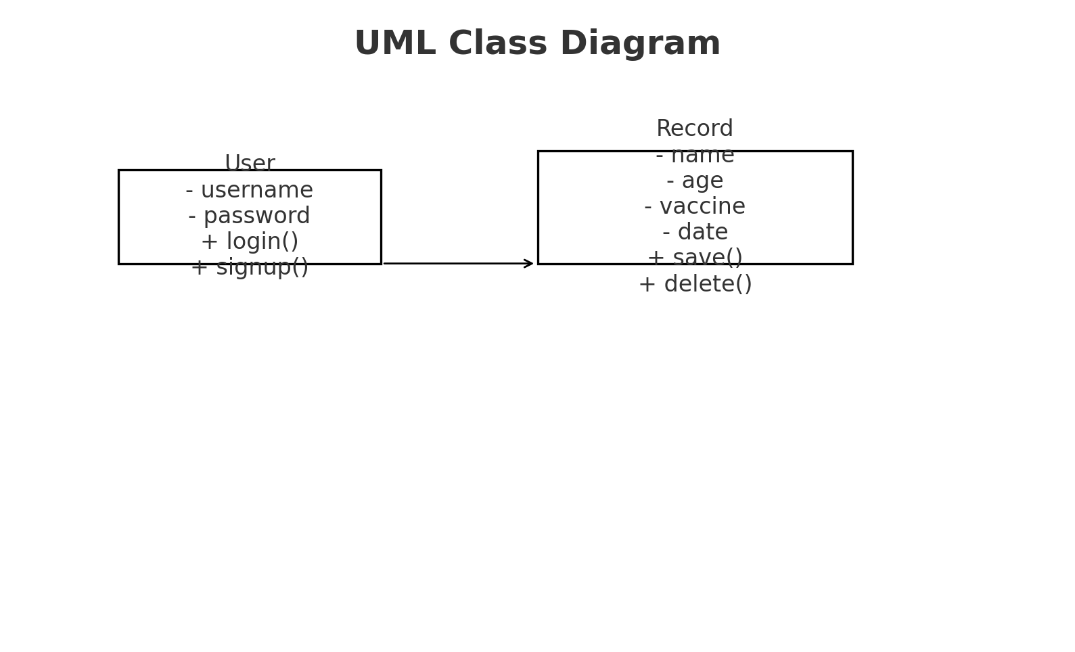
UML Class Diagram



Appendix - Key Code Snippets
Key code constructs:
- localStorage keys: 'users', 'records', 'currentUser'.
- nextDoseSchedule object mapping vaccine to interval in days.
- Certificate generation: opens a new window with printable HTML and calls print().
- Export CSV: constructs CSV string and triggers Blob download.

